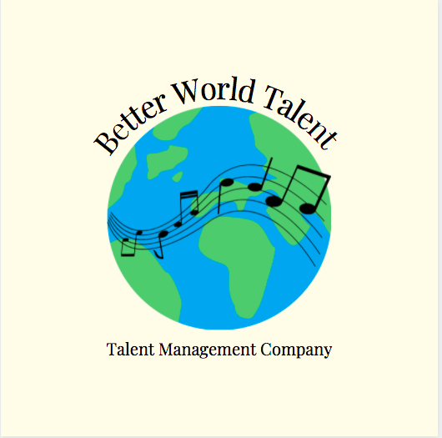
Client Action Plan
Executive Directors
Drake Wolf & Courtney Lynn Povero

Table of Contents
Executive Summary ……….……………………………………………………………………………..Page 3
Artist Roster…………………………………………………………………………………………………..Page 4
Artist Introduction…………………………………………………………………………………………Page 5
Artists Vision, Mission, and Purpose…………………………………………………………… Page 6
Long term goals ………………………………………………………………………………………….…Page 7
Short term goals (SMART)…………………………………………………………………………….Page 8
SWOT artist…………………………………………………………………………………………………….Page 9
SWOT company……………………………………………………………………………………………...Page 13
Promotional action…………………………………………………………………………………….....Page 15
Creative Output Actions…………………………………………………………………………………Page 18
Budgeting……………………………………………………………………………………………………….Page 22

Executive Summary
At Better World Talent we foster a supportive and open environment that encourages and empowers those who seek rightful representation. Our organization works with our talent to create and provide opportunities that align with their career goals and offer every resource available to those who join our team. We function as an independent agency and offer both in-house managers and agents that work to create meaningful and positive relationships while keeping the interest of the artists at the forefront of all decisions. All artists are welcome and encouraged at Better World Talent as we have created an integrated system with specific managers and agents prepared to aid in music, film, and live theatre. Through the love of entertainment we all unite under one organization to celebrate and promote the power of art and it starts with the creative minds of those we represent.

Drake Wolf is an ideal client as he holds ideals to Better World Talent. Drake’s passion towards the LGBTQIA+ community and his active work to make everyone feel welcome and appreciated aligns with our vision of making the world a better place. We believe Drake will be successful in the music industry as he is dedicated to his art form and has already shown great work ethic. With our help Drake will be able to accomplish his goals of releasing an EP, building a website, and creating merchandise among other creative opportunities. By partnering with Better World Talent Drake will be able to see his dreams come true while discovering his true potential.
Vision - Better World Talent
We enrich our facilities and studios with positive and forward thinking individuals who also value the importance of making the world a better place. Through self growth and development comes one’s true light and with that, they can change the world. We nurture our clients to be confident and authentic throughout their journey as an artist to guarantee success. Whether as an employee, artists, or appreciator of arts, we are all interconnected through the world of entertainment.

Artist Roster
Adam Krost Kaleb Krown Daija Reed Rose Adelia
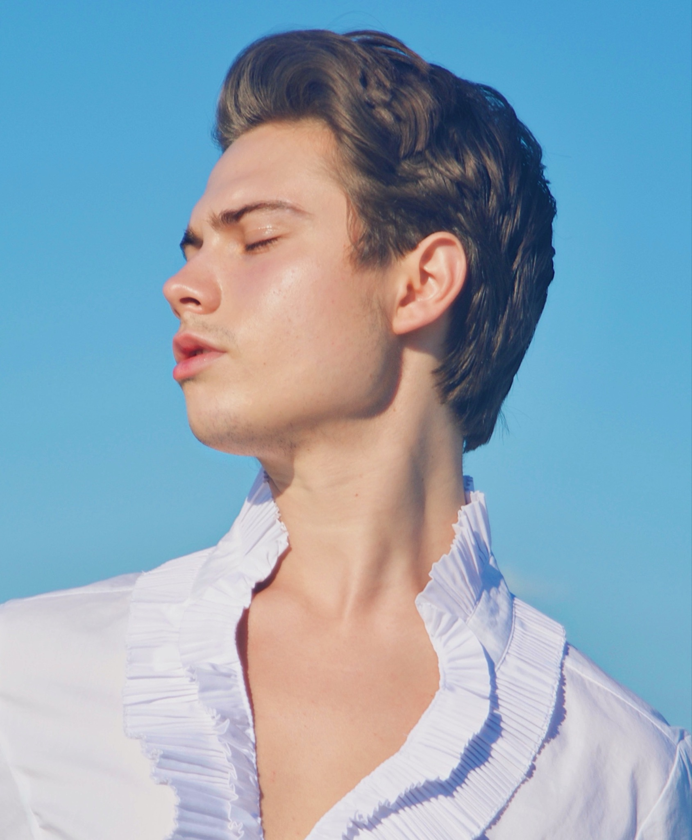
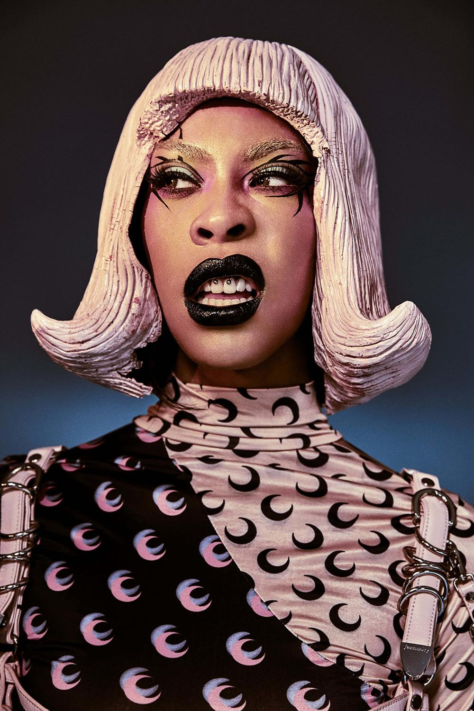
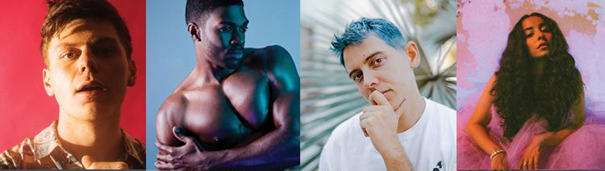
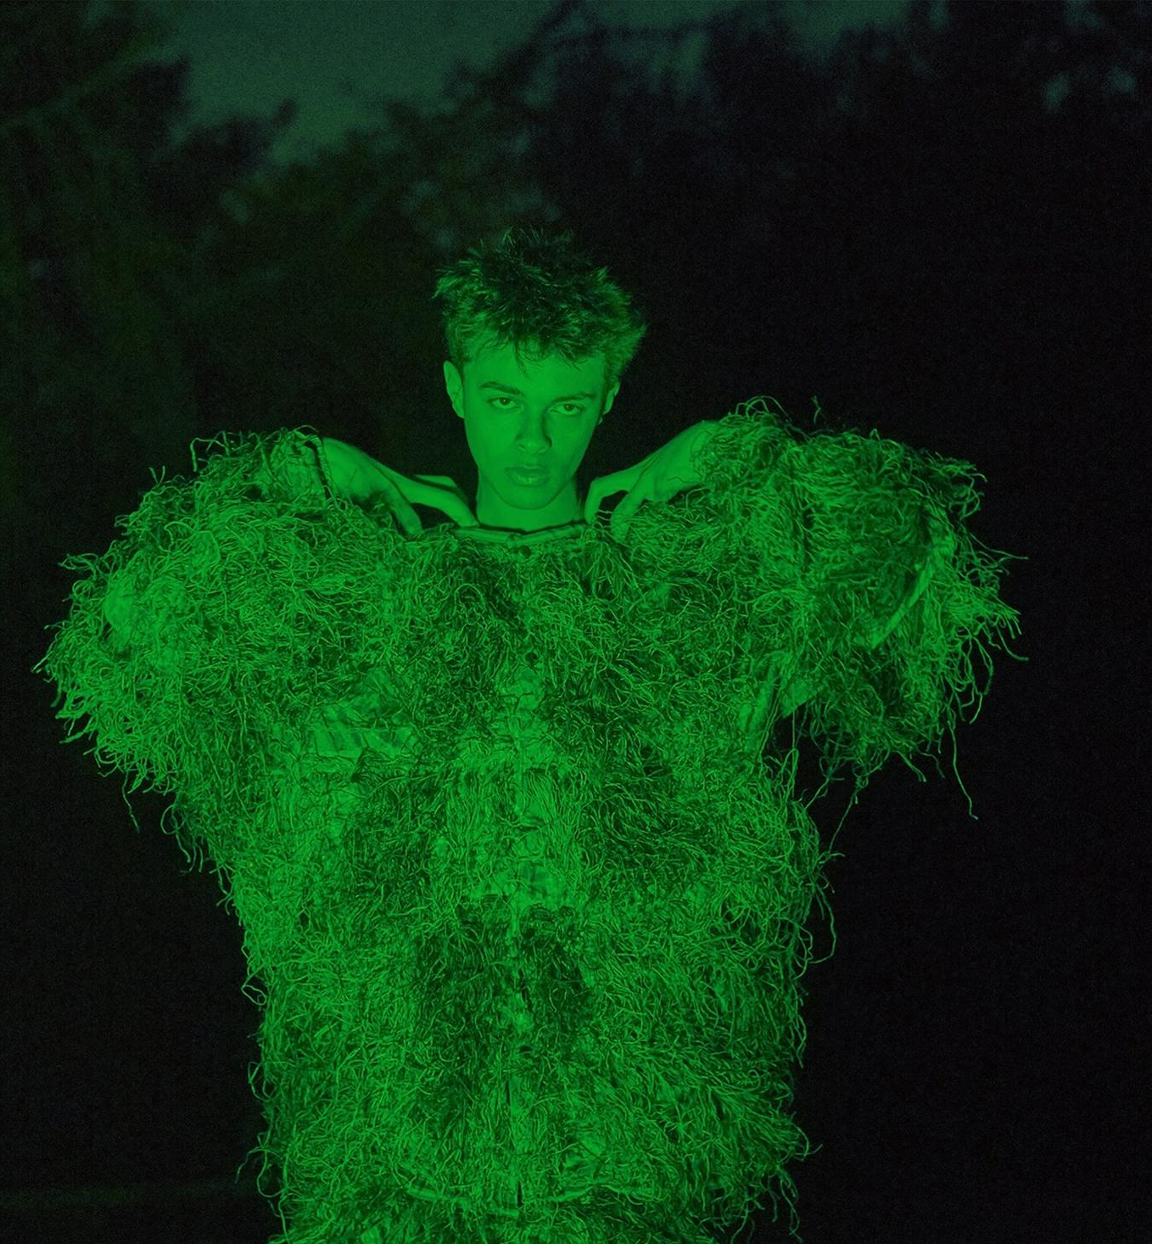
Stella X Ava Fawn Isaac Dunbar Kelly Fever Drake Wolf
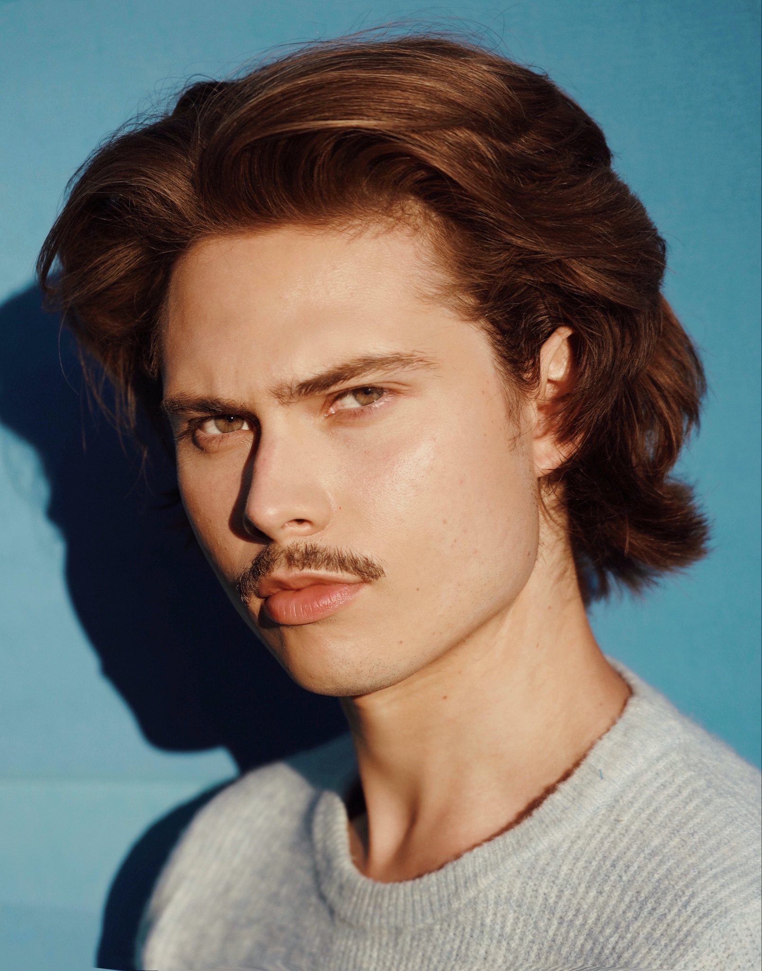
SPOTLIGHT ARTIST:
DRAKE WOLF
(he/they)

Drake Wolf is a 21 year old Artist originally from Bel Air, Maryland. He grew up loving to play dress up and take the stage singing his heart out with original songs. Being queer has had a huge influence on Drake’s art throughout the years. He loves expressing himself through high fashion, androgenous clothes and introspective music. They started producing music Junior year of high school with friends and fell in love with building songs up from the ground. Some of his biggest influences are Chet Baker, Frank Sinatra, Lana Del Rey, BORNS, and Elvis. There is definitely a vintage quality to their vocals that is both haunting and pleasing to listen to.

Drake’s Mission

By creating a network of music professionals in the industry, writing deep; introspective, nostalgic music, and gaining a large social media presence, Drake plans to enhance people's lives, most importantly the lives of LGBTQIA+ individuals.
“My main focuses in music are to create fantasy, promote advocacy, and encapsulate queer beauty sonically.

Drake’s Vision

Drake envisions a world where lines divide and people can exist together without hatred. Drake strives to promote respect for the identities of all individuals. He strives to sonically depict the queer experience- with all of the triumphs and all of the struggles. Within the next ten years, Drake Wolf will be a household name music artist who creates contrasting musical representations of his identity and work towards LGBTQIA+ rights. Drake will also earn a Grammy award for one of his studio albums.

Drake’s Purpose

Almost all people in the LGBTQIA+ community struggle to come to terms with their identity while growing up because of various hardships. Whether that is because of being bullied, disowned, unaccepted, confused, or others, Queer people … Drake wants to be show Queer people of all ages that it is absolutely okay to be who you are. To be fearless and authentically yourself. To understand that it is okay to be different, okay to be confused, okay to be sad. We are all valid, and Drake wants to promote this.

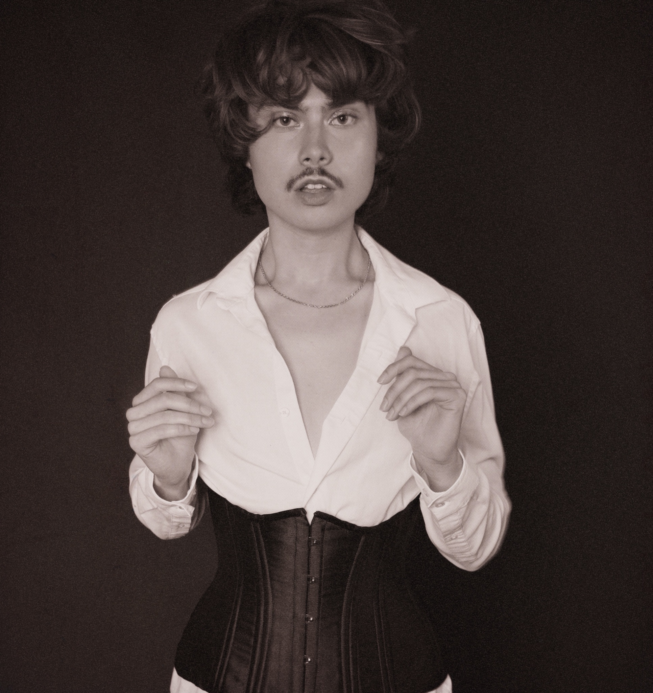
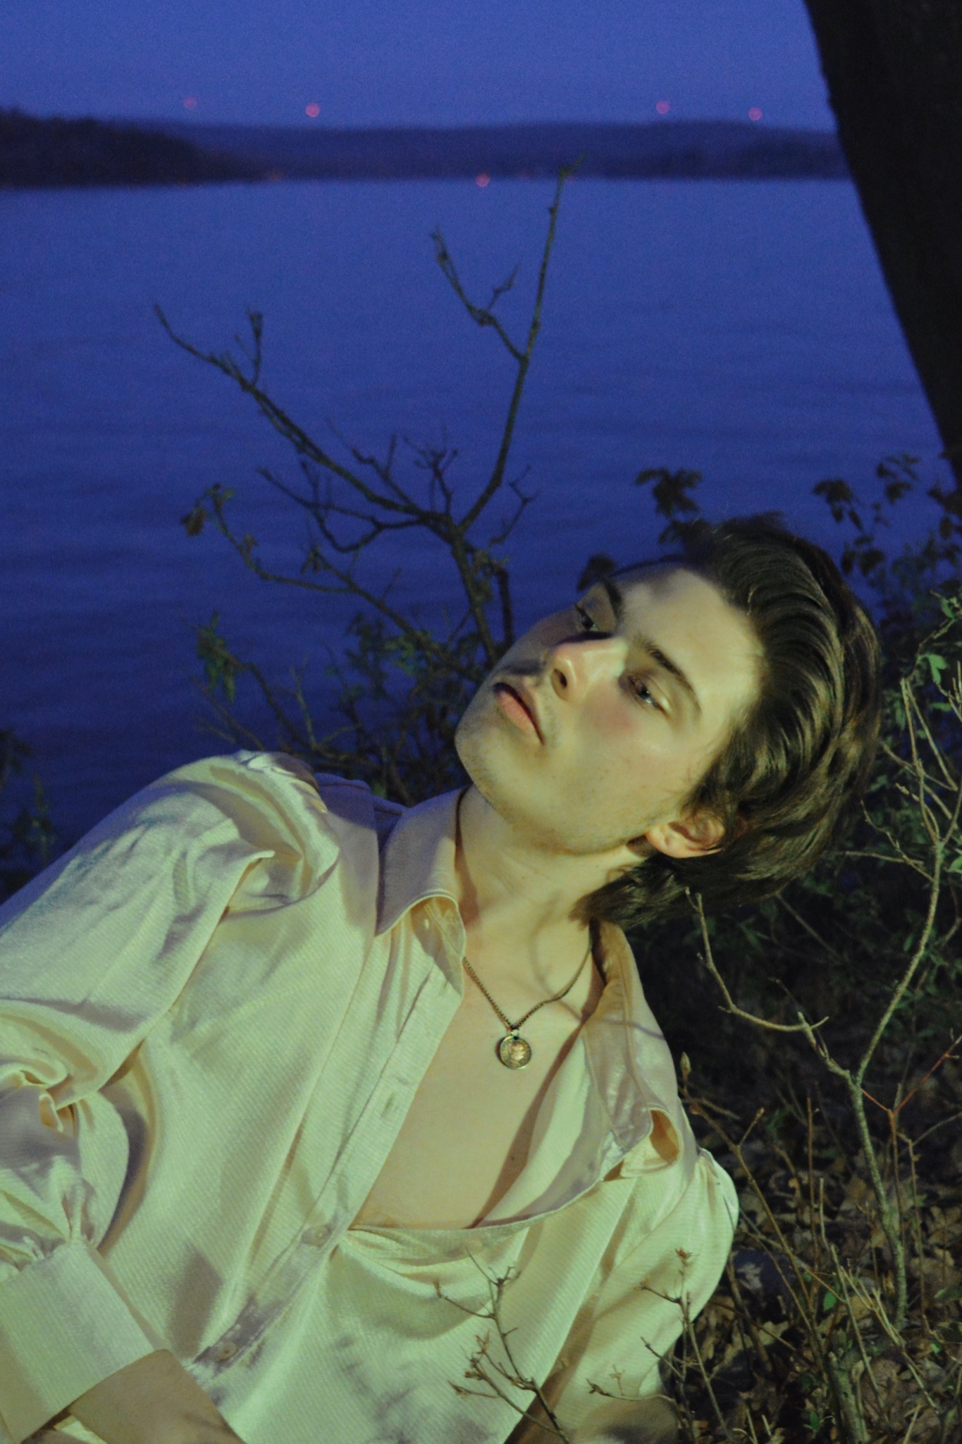
GOALS

Long Term Goals:
- Release Debut Album and get 100,000 streams
- Reach 500,000 Listeners, 1,000,000 grossed streams
- Become Brand Ambassador
- Go on Solo Tour
- Get invited to major Talk Show

Short Term Goals:
- Put on major Spotify Playlist
- Trip to Los Angeles to meet with producers
- Open for band or semi-famous popstar
- Reach 10,000 Monthly Listeners
- Featured on Podcast
- Small Brand Collaboration
- Record Vocal Reels

Manager To-Do List:
- Discuss with Drake his goals and brand for his career
- Meet with other managers in LA and NY (for possible collaboration)
- Hire intern to manage social media and assist in shoots
- Schedule writing sessions and collabs with other artists (larger and smaller)
- Hire and schedule times to meet with producers
- Hire booking agent to plan gigs and shows
- Coordinate photoshoot for social media content
Accomplishments
Bloomy Award for “Best Song Writer”
N.E M. F Award for “Best Upcoming Artist
Release of “Sugar” collaboration

Historical References
Drake has been compared to artists such as:
- Prince
- Freddy Mercury
- Isaac Dunbar
- Lana Del Rey
- Billie Eilish
- BORNS

Drake Wolf desires to explore the history of Queer people in his music and discover what music may have sounded like back in time periods where Queer people were not accespted. Re-imagining the past with contemporary viewpoints
SWOT of DRAKE WOLF

Strengths:
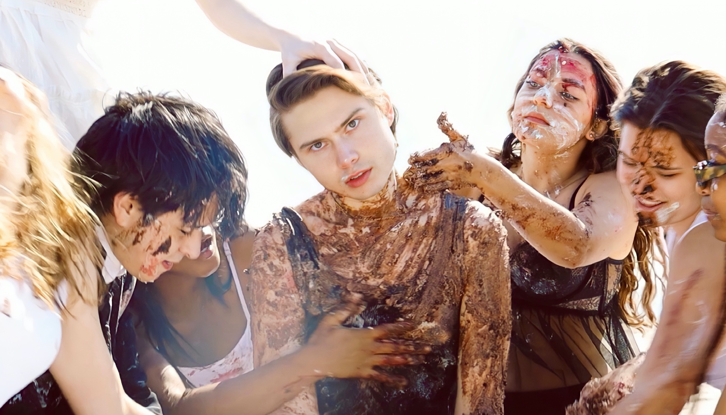
Drake Wolf is a vibrant young artist with ambition that will only serve him on his journey as an artist. His hunger and drive for this industry sets him apart from other talents as he is not afraid to get his hands dirty and put in the work to be successful. One of his biggest strengths is his vocal and artistic versatility as he will be able to keep his artists engaged and excited to guess what he will do next.

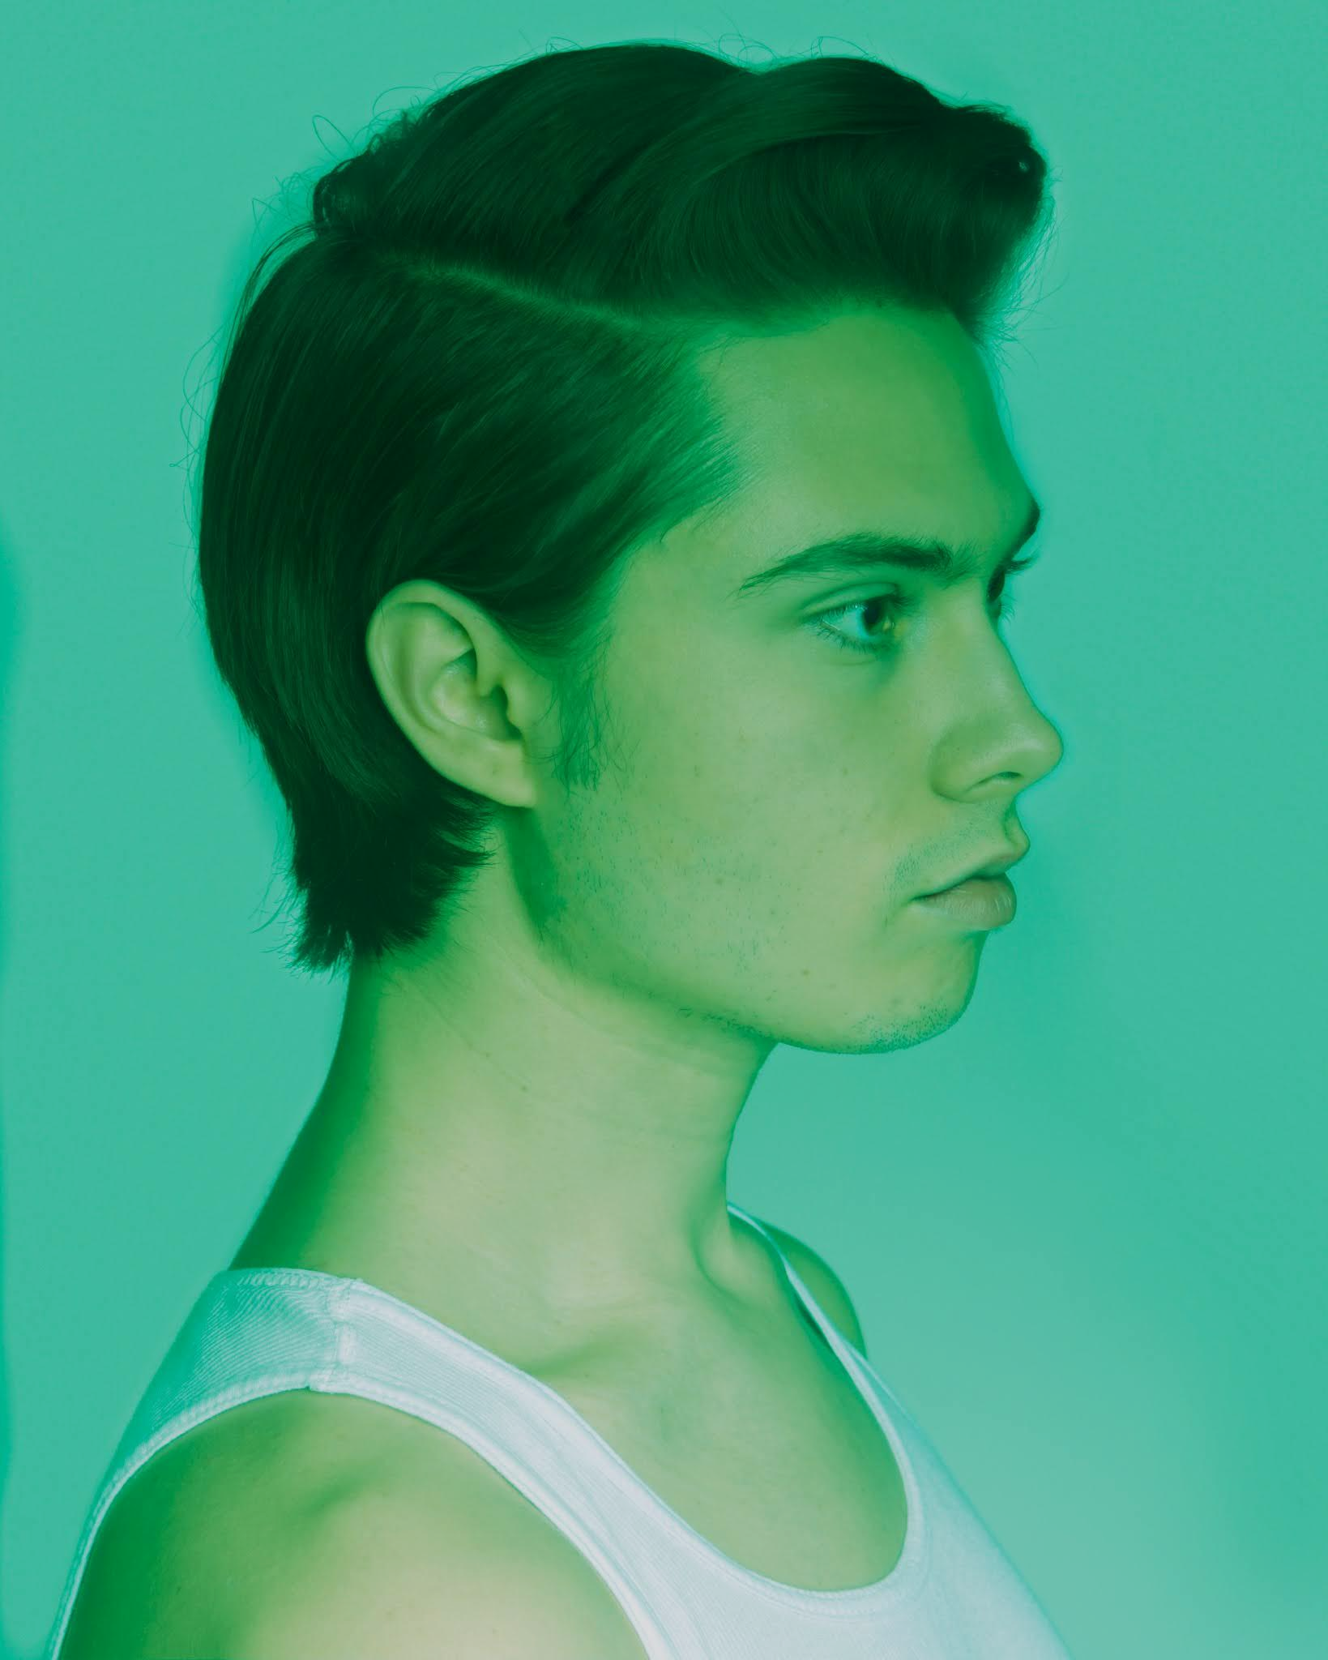
Drake is a well rounded individual filled with knowledge. Before joining Better World Talent Drake managed himself and is able to give a very clear vision of his career. He works in collaboration with his team to make his vision come to life and is very hands-on in the trajectory of discovering himself as an artist. Him having this drive and clear vision serves Drake as he is able to make executive decisions for himself and work cohesively with Better World Talent.

Weaknesses:
While Drake is a very promising new artist, his newness to the industry will be a challenge for him to overcome. He has the potential to become a very well known artist however he will have to work hard at getting his name out there and becoming a familiar face. However this can serve as a strength as many search for unknown talent and wish to work with new faces. He is not clouded by an already made persona of him as an artist and has the freedom to create his own image. He will have to work harder as an openly queer, more feminine presenting artist to appeal to wide audiences- his art fitting a niche may be a good thing, but could ultimately hold him back from getting on mainstream radio.

Drake is not one who can sit about waiting for his time to shine and often takes on many projects and duties that cause his schedule to fill up. While it is great to have an artist who is excited and a go-getter it also serves as a weakness as he seems to take on too much at once. Not only is he a music artist, but also an actor, and photographer. This can be managed as he is aware of this downfall and is actively working to lighten the load and take on projects that truly matter to him. However, his ambition and ability to take on different art forms will help him land jobs for income when he is not working in music.

Opportunities:
Drake has worked to create a large network of artists and other industry professionals. His proactive approach to creating relationships with those in the industry gives him more opportunities while working with those he trusts.

Drake’s passion for advancing the LGBTQIA+ community is a great advantage to further his mission and vision. This creates many opportunities to reach and create new material that is exciting and never before seen. Working in this specific market will open an abundance of opportunities.

Threats:
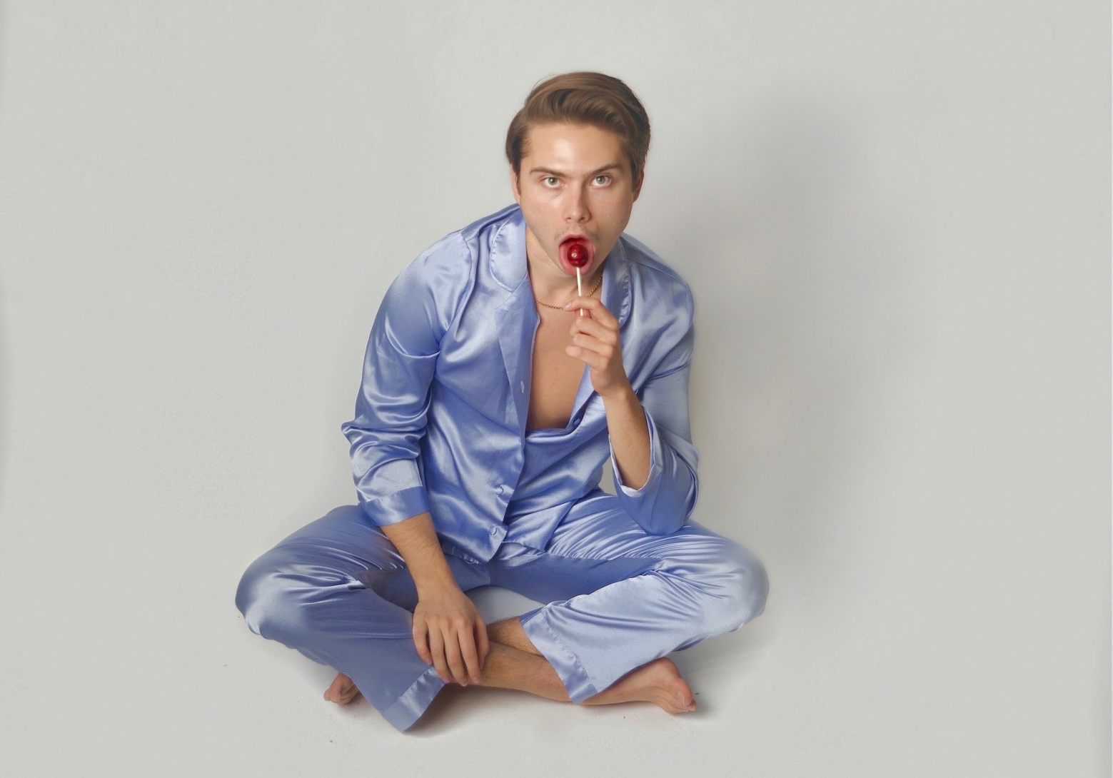
One of Drake’s biggest threats is the large competitive talent pool that is ever growing. He has the challenge of competing against others who have trained and worked hard just as he has. Due to Drake’s determination and passion for the entertainment industry this threat will only drive him to work harder and seek out all opportunities.

SWOT of Better World Talent
Strengths:
Better World Talent is dedicated to working with their artists and helping them find their voice. We work very closely with our artists to create more than a business relationship but a partnership. There is no way to successfully promote an artist without knowing who they are as a person and we at Better World Talent emphasize this by creating meaningful relationships.

Better World Talent has a great reputation and because of this many want to work with and through our company. Having a positive reputation serves us as we are a trusted entity in the community and work to continue this reputation into the future.

Weakness:
As we are a growing company, we are in need of hiring more employees to accurately represent all of our clients. While we are in a good position at the moment we are falling behind in growing our administration. This weakness can be addressed by searching for those in the community and beyond who are passionate about the entertainment industry and making the world a better place.

One of our greatest weaknesses is our financial state as a company. While we are very passionate and determined to give our clients the greatest representation possible this is an aspect of Better World Talent that can be improved upon. There is the opportunity to create other revenue streams and this is one of Better World Talent’s goals.

Opportunities:
We have worked closely with many organizations and because of this we are often used as a main contact when searching for talent. Our connections serve as an opportunity to our talent as well as to our staff in creating the best possible outcome for our clients and our business.

We attend national conferences to build our network as well as promote our artists. These conferences allow our company to learn from others and give us the opportunity to better our organization.

Threats:
One of our biggest threats as a company is the hundreds of other competing talent agencies. There are other companies that have been around longer than Better World Talent giving them the advantage of having a larger network than us.

We represent very unique artists with strong passions. It is possible our artists will be overlooked because of their identification and presentation. While many could view this as a downfall for Better World Talent, we view this as an opportunity for our unique artists to change the mainstream talent scene.

Promotional Actions

- Greater Social Media Presence
This is one of the quickest ways to get Drake’s name out there. This is also a way for others to share his media and promote his content. This will be Drake’s main form of communication with his followers and he is able to create connections with his viewers. In order to accomplish this goal we will create a social media calendar built around Drake’s work, what he has coming up, and whatever else he wishes to promote. This is an organized way to make sure this task does not fall to the back and is updated frequently.

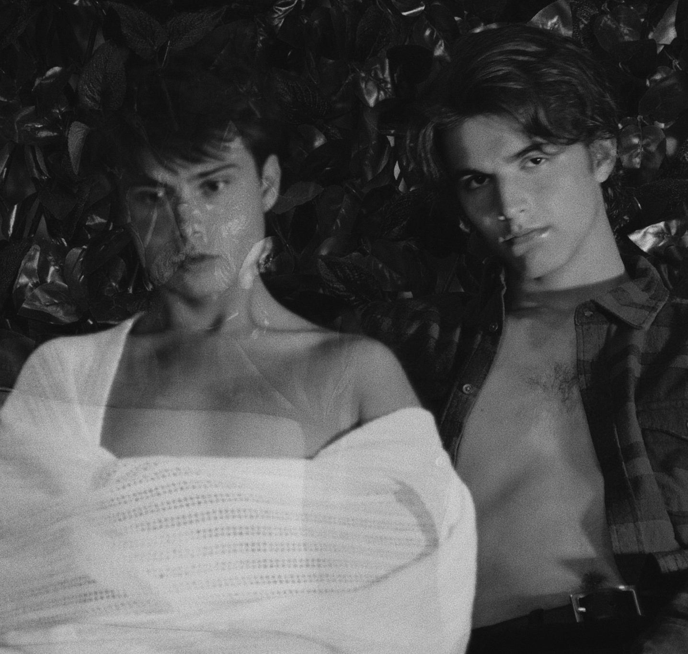
- Create Eye Catching Teasers
Creating these videos, images, and behind the scene teasers will give Drake’s viewers a closer look into his life which creates a greater connection with his fans as well as sharing his process of building his own brand. It will be a way for him to interact with his fans as well as promote his art. These videos will be featured on Drake’s social media as well as his website. We will begin by brainstorming concept ideas for the videos, deciding if they are weekly check ins or a series, for instance on Instagram TV. We will hire a social media expert to make the videos presented in a sophisticated manner and are engaging.

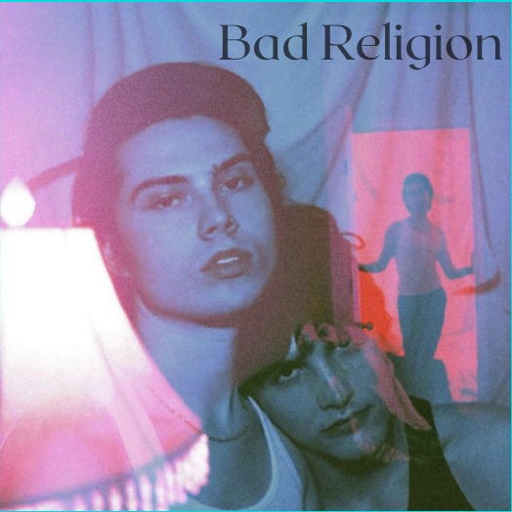
- Market Media through instagram & tik tok promotions
Through the promotional options through instagram and tik tok we will be able to reach thousands of other targeted users. The promoted content will include new music, merchandise, and single releases. In order to see this through we will begin budgeting for CPM (cost-per-mille, cost per 1000 views). We will also book photo sessions to ensure Drake has enough content for his social media
.
- Create a community
Creating a community within your followers is an important way to make
lifelong connections to those who support you. Drake is passionate about the LQBTQIA + community and finds himself creating his most meaningful relationships therewithin. While this is his targeted community Drake is eager to build his community and reach as many people in order to unite people together and bond over emotions and feelings that everyone has, regardless of their identity.
- Build a Website
  - This is where those wanting to learn more about Drake and his work can find his information. Drake’s website will be a place for his fans to buy tickets and merchandise, links to all socials, as well as contact and booking information. To get this started we will hire a web designer to create a unique and engaging web page specific to Drake. We will also host a photoshoot for Drake to have up to date looks as well as personality photos to feature on the website.
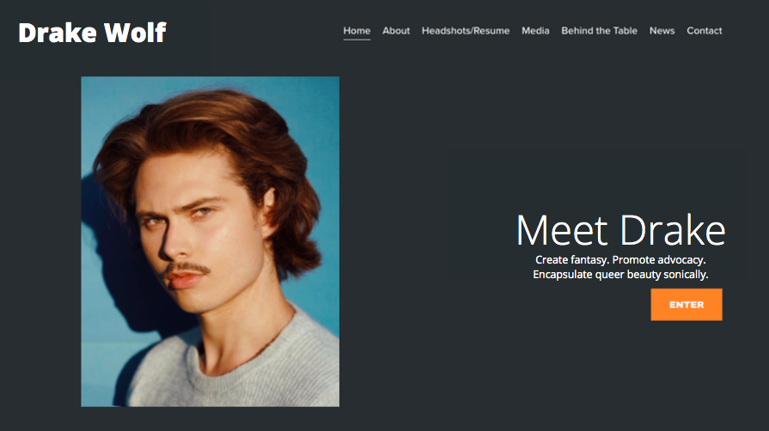

Creative Output
- Release EP
  - Drake will work to release his first EP within the first year of partnership with Better World Talent. This is a great way to ease into his career as a new artist and engage his audiences with music that truly shows off his talents. We will search for compatible recording studios and producers. We will also hire songwriters to help Drake with his songwriting journey.
- Make Music Video
  - Producing a music video is a great way for Drake’s fans and the industry to see his performance skills, creativity, and brand. It gives viewers the chance to put a face to the voice they hear through their speakers. We will hire a videographer to help conceptualize the video. We will search for a studio or various venues and locations we would like to film in and follow any procedures necessary to gain clearance.

- Apple Music Exclusive Experience
  - The apple music exclusive will give those who are subscribed an exclusive look into Drake’s music. While they listen to his music, behind the scene commentary is displayed on the screen to give a closer look into the songwriting process and Drake’s lyrics. This will give his listeners a better understanding of Drake as an artist and his music. We will set up a spotify studio interview
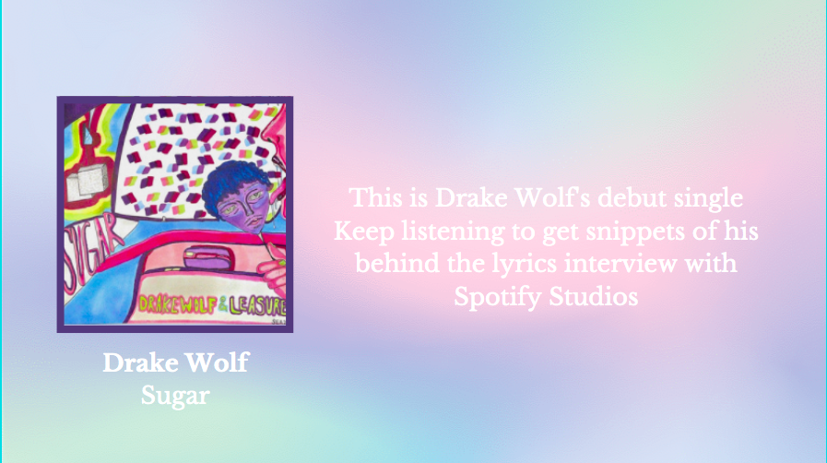

- Release Merchandise
Releasing Merchandise will not only connect Drake to their fans but will also generate publicity as merch is a “walking billboard” Selling merch will also generate an income to help recoup costs. We have drafted some ideas for what Drake Wolf merch could look like:

T Shirts, Hoodies
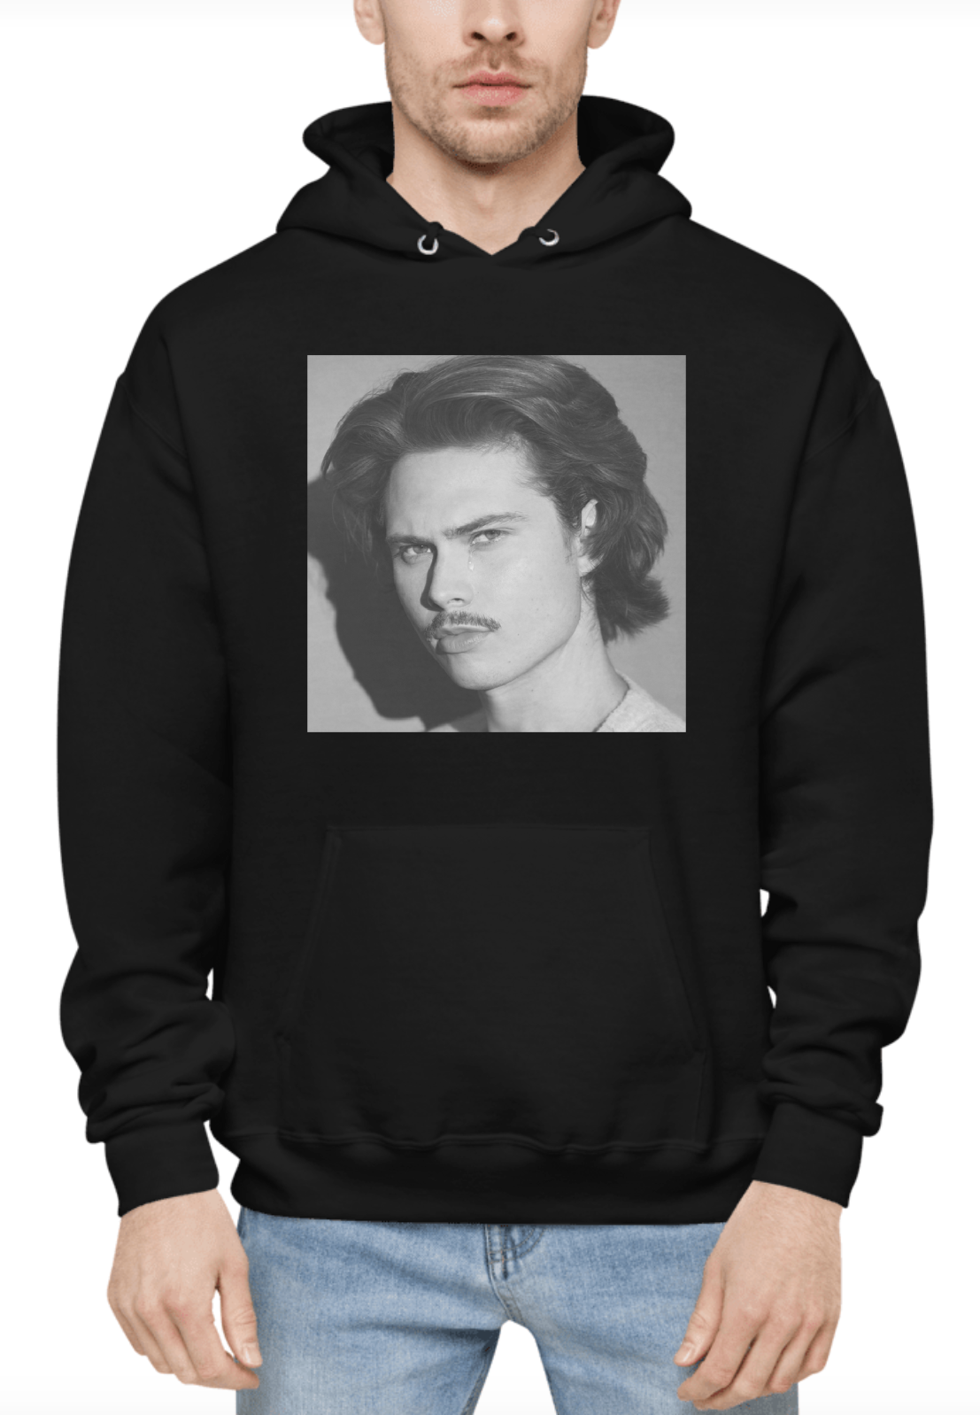
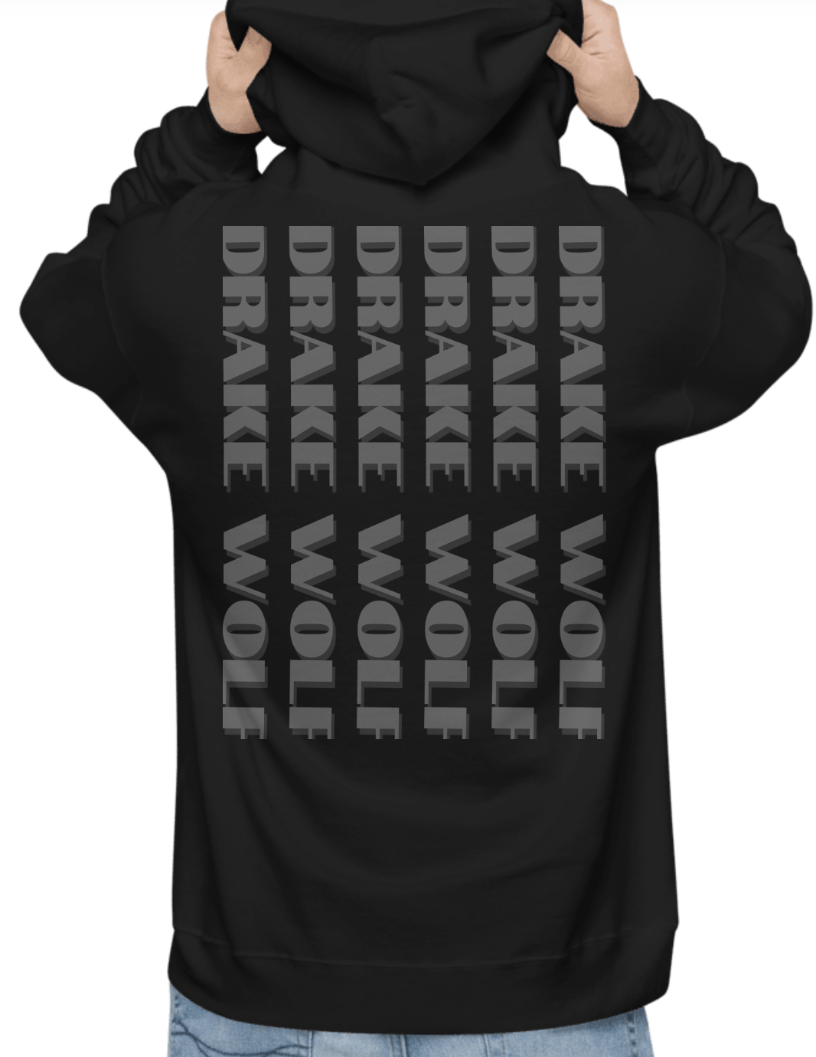

Tee Shirts and Hoodies are an essential product that fans constantly ask for and desire! This Drake sweatshirt is comfy and chic, leaving Drake’s fan cozy and showing off the artist whom they love!

Corset
Drake’s brand is based in their queerness- He takes enjoyment in playing with gender expression and encourages his audience to do so as well. Releasing corsets will be a beautiful way to connect Drake with their audience and give them everything they never knew they needed!
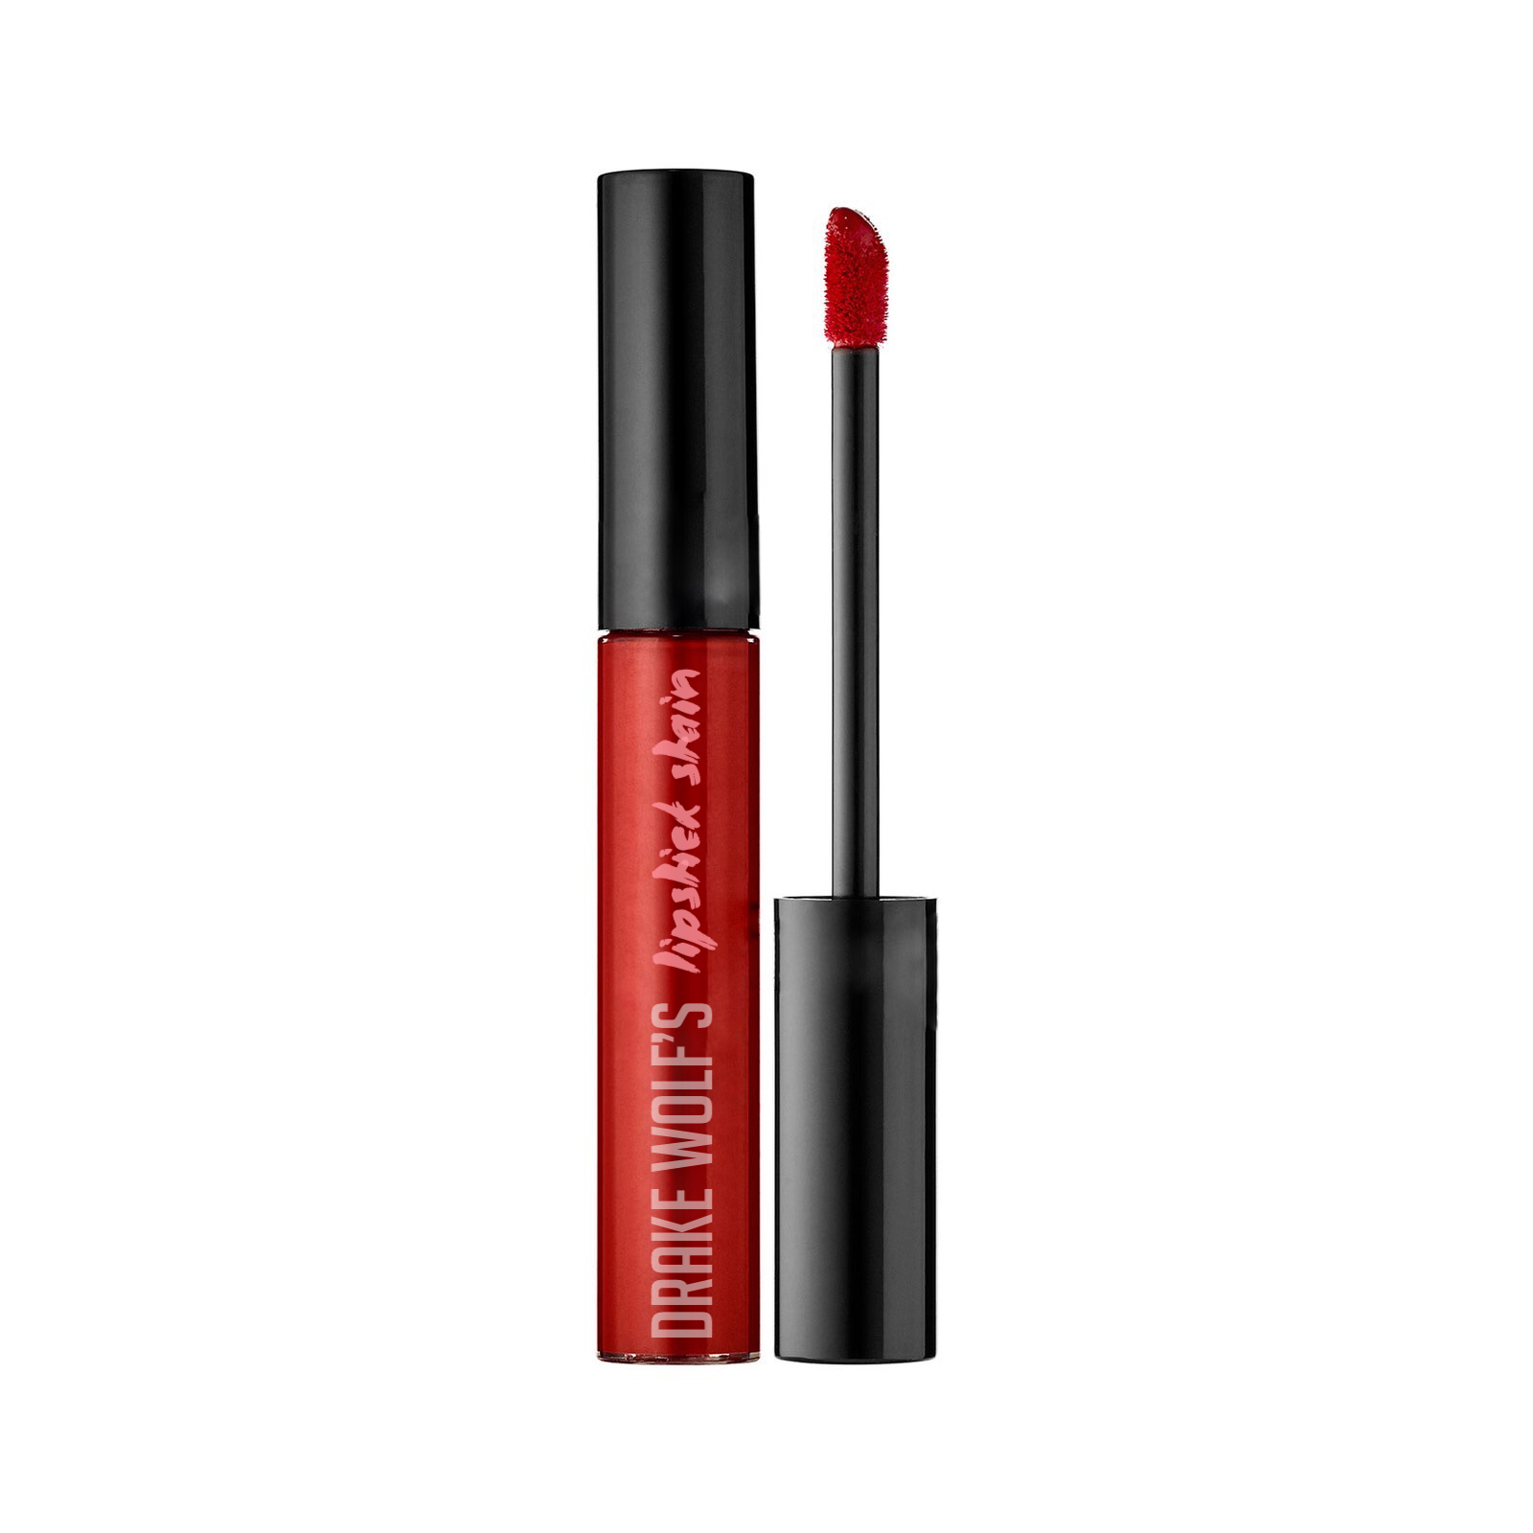
Lipstick Stain
One of Drake’s “essentials” is his LipStick stain that they store in their purse at all times! This will be another way to establish a connection and feeling of having a product that the artist they love also uses. This will cross the boundaries of social media and music to establish real fan-artist relationships

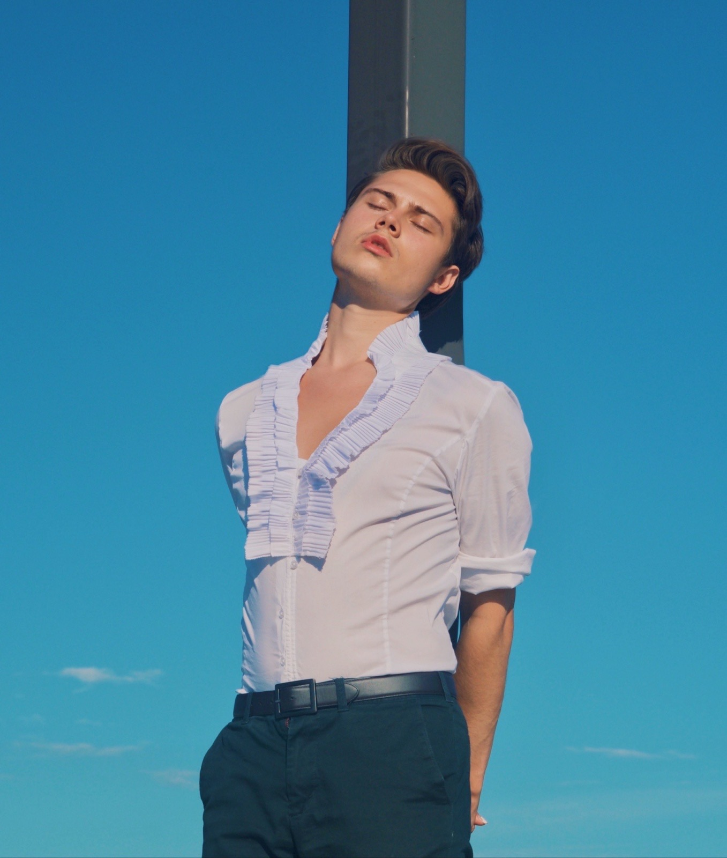
Current Budget Analysis
Monthly Expenses
Rent/Utilities (NYC) $1,000/month
Food/Dining out $900/month
Metrocard/Transportation $430/month
Birthdays, Christmas Gifts $200/month
Groceries $200/month
Promo $300/month
Social Media Manager $500/month = $3530

Monthly Earnings
Day Job $4,000/month
Local Gigs $700/month
Streams $200/month
Merchandise $50/month
Royalties $60/month
Voice Lessons $400/month
Photography Shoots $600/month
= $6,010

Creative Output Budget (Every 3 Months)
Releasing EP Expenses
Musicians $700
Recording $1,000
Producing/Mixing $1,000
Mastering $500 Distribution (digital/vinyl) $1,o00

=$4,200

Total Revenue: $380
Final Summary

Here at Better World Talent, we aim to put our clients' names out in the industry, as well as guide them and develop their individual brand. Because of our reputation, we have been able to sign a diverse group of LGBTQ Artists who continue to put out exciting new work. We aim to continue to work towards satisfying and expanding our niche so we continue to gain credibility and financial stability.

Drake Wolf is an ideal artist for our company as they are artistically captivating, unique, progressive, and versatile. We know Drake will be able to successfully establish a long lasting career in music. With our help, Drake will create a substantial network of music professionals in the industry that will help Drake develop his craft, enhance social media presence, and book venues.

Music and art is in Drakes blood. For as long as they can remember, music has been a part of their life and has helped navigate the struggles of self discovery and identity. By partnering with Better World Talent, Drake will continue this journey with his fans as he promotes Queer activism through sonical works of art.

